IT RCSA Audit Documentation
Access Certification 2026 Q1 PAM BSI SOX
  - Network Device Admin Account Review (BSI.IT.27.C7)
ASSESSMENT  FAIL | TEST PERIOD  JUL 2025 - JUN 2026 | EXCEPTIONS  3 TYPES (E1-E3)

Purpose
To document the IT RCSA review of the 2026 Q1 quarterly privileged access certification for BSI network devices (Sample 2 of 2 for the testing period July 1, 2025 - June 30, 2026), including the privileged network AD groups defined in the PAM Definition of Privilege, the certification population reconciled to Active Directory, reviewer assignment (managers and account owners), review decisions, the appropriateness of approved access, revocation of inappropriate access within SLA, and compliance with the PAM Recertification Procedure and the IAM Standard.
Testing period | July 1, 2025 - June 30, 2026 (samples: 2025 Q3 and 2026 Q1)
Sample quarter | 2026 Q1 (quarterly PAM access certification) - Sample 2
Certification | 2026 Q1 PAM BSI SOX Manager Certification and 2026 Q1 PAM BSI SOX Entitlement Owner Certification
Privileged groups sampled | CISCO ISE Administrators; CISCO Network Administrators; ISEAdmin; F5FullAdmin
Campaign launch | April 9, 2026 at 12:07 PM (Manager) / April 9, 2026 at 12:37 PM (Entitlement Owner)
Review decisions | 61 memberships: 58 Approved, 3 Revoked (decisions April 10 - April 30, 2026)
Overall conclusion | Not compliant - 30 memberships approved for disabled, terminated or re-granted accounts (E1-E3)

1. Executive Summary
IT RCSA reviewed the 2026 Q1 PAM BSI SOX access certification for the four privileged network AD groups defined in section 3.3 of the PAM Definition of Privilege, the BSI Active Directory extract of May 15, 2026, the Netwrix revocation logs and the 2025 Q3 evidence. All 61 memberships (51 users / administrators and 10 service accounts) were included in the certification and reconcile to Active Directory, were reviewed by the user's line manager or the account owner, and received a final decision; the three revocations were removed within one day. However, 30 memberships in CISCO Network Administrators and ISEAdmin were approved on April 30, 2026 although the AD account had been disabled since April 2-3, 2026 (E1), the identity carried an IAMS termination date of 12/31/2024 (E2), or the membership had been revoked in the 2025 Q3 review and re-granted without an approved request (E3). The sample assessment result is Fail. Sample 1 (2025 Q3) also failed and the 2026 Q2 certification (after the period) shows the same exceptions.

2. Sample and Scope
Privileged AD group | Memberships certified | User type | Scope result
CISCO ISE Administrators | 3 | 1 person / 2 service | Matched to AD
CISCO Network Administrators | 29 | 24 person / 5 service | Matched to AD
ISEAdmin | 24 | 23 person / 1 service | Matched to AD
F5FullAdmin | 5 | 3 person / 2 service | Matched to AD

3. Testing Performed and Results
Attribute | Evidence evaluated | Result | Conclusion
Frequency (A1) | Certifications in the period: 2025 Q3 (launched August 1, 2025) and 2026 Q1 (launched April 9, 2026); 2025 Q4 not provided; 2026 Q2 launched July 22, 2026 (after the period). | Pass (observation) | One review in each half of the period; 2025 Q4 not evidenced and 8.3 months between launches (Procedure requires quarterly).
Population completeness (A2) | BSI AD extract May 15, 2026 compared to the 61 certified memberships. | Pass | All 58 AD members certified; the 3 additional certified memberships were revoked and removed.
Reviewer (A3) | Decision makers compared to the identity, line manager and account owner. | Pass | Line managers (person) and owners (service accounts); no self-review.
Review completion (A4) | 61/61 memberships with a final decision; decisions April 10 - April 30, 2026. | Pass | Review completed and signed off.
Appropriateness of access (A5) | IAMS status in the certification, AD status (May 15, 2026) and 2025 Q3 decisions / AD (November 25, 2025) compared to approved memberships. | Fail | 30 memberships approved: E1 AD disabled MIA25103, MIA25249, MIA25250, MIA25251, X533062, X688027, X689040, X689379, X690623; E2 IAMS terminated MIA25103, MIA25104, MIA25105, MIA25106, MIA25142, MIA25249, MIA25250, MIA25251; E3 re-granted MIA25142, MIA25172, MIA25175, X453396.
Revocation within SLA (A6) | N596764 (CISCO Network Administrators, ISEAdmin) revoked and removed April 24, 2026; MIAYPER (F5FullAdmin) revoked April 16, removed April 17, 2026 (Netwrix). | Pass | Revocations completed within 30 business days and absent from AD on May 15, 2026.
Information reliability (A7) | Certification export, AD extract, Netwrix logs. | Pass (observation) | Reports reconcile; export rows repeated 5 times; IAMS termination date inconsistent with AD expiration.

Conclusion: The sampled certification is not compliant. Exceptions E1-E3 were identified in CISCO Network Administrators (16 of 29) and ISEAdmin (14 of 24); CISCO ISE Administrators and F5FullAdmin passed.

4. Referenced Excel Workbook - Tab-by-Tab Guide
Purpose. The referenced workbook (BSI.IT.27.C7.02 Q1 2026 Cert.xlsx, provided in BSI.IT.27.C7 Final 07.2025-06.2026) contains the population, Active Directory and revocation evidence for this sample; BSI.IT.27.C7.05 Testing Walkthrough documents the testing step by step. The summary below allows a reviewer to trace each conclusion without interpreting the workbooks independently.
Workbook tab | What the tab contains / purpose | Reviewer use and sample traceability
Q1 2026 Cert - NETWORK ADMINS | Extract of the PAM Definition of Privilege section 3.3 (March 2025). | Confirms the four groups in scope (Appendix A).
Q1 2026 Cert - 1.Cisco ISE Administrators | AD extract May 15, 2026 with group members tagged; full 2026 Q1 SOX Manager and Owner certification exports. | 3 memberships certified and Approved; no exceptions.
Q1 2026 Cert - 2.Cisco Network Administrators | Same layout; REVOCATION EVIDENCE (Netwrix) for N596764. | 29 memberships; 16 exceptions (E1-E3). Appendix B exhibits B1, B3, B4, B5.
Q1 2026 Cert - 3.ISEAdmin | Same layout; REVOCATION EVIDENCE for N596764. | 24 memberships; 14 exceptions (E1-E3).
Q1 2026 Cert - 4.F5FullAdmin | Same layout; REVOCATION EVIDENCE for MIAYPER; NOT INCLUDED evidence for Francisco Roman (added 4/16, removed 4/17/2026). | 5 memberships; revocation removed within SLA; no exceptions.
BSI.IT.27.C7.05 - 3_Attribute Matrix | Attribute table for Sample 1 (2025 Q3), Sample 2 (2026 Q1) and 2026 Q2 (corroborative). | Group-level results used in Section 3.
BSI.IT.27.C7.05 - 4_Item Detail / 5_Exceptions | Every membership with source row, IAMS and AD status and per-attribute result; exception trail per account. | Supports Section 3 and Appendix B.
Reviewer traceability
- Scope path: PAM Definition of Privilege section 3.3 -> NETWORK ADMINS tab -> group tabs 1-4 -> Appendix A.
- Population path: AD extract May 15, 2026 (tabs 1-4, rows 14-2467) -> 2026 Q1 certification (tab 2, rows 2470-4851) -> Exhibit C1.
- Exception path: certification row -> AD status -> 2025 Q3 decision / AD November 25, 2025 -> BSI.IT.27.C7.05 tab 5 -> Exhibits B3 and B4.
Note: Each row of the 2026 Q1 certification export appears 5 times; memberships were de-duplicated by account, group and decision before testing.

5. Evidence Index and Audit Trail
Source | Purpose | Key support
BSI.IT.27.C7 Final 07.2025-06.2026 / 02 Evidence 07.2025-06.2026 / BSI.IT.27.C7.02 Q1 2026 Cert.xlsx | Sample population, decisions, AD, Netwrix | 2026 Q1 certification (launched 4/9/2026), AD extract 05/15/2026, revocation logs.
BSI.IT.27.C7 Final 07.2025-06.2026 / 02 Evidence 07.2025-06.2026 / BSI.IT.27.C7.02 Q3_2025.xlsx | Sample 1 and prior revocations | 2025 Q3 certification, Netwrix removals 9/2-9/8/2025, AD extract 11/25/2025 (re-granted memberships).
BSI.IT.27.C7 Final 07.2025-06.2026 / 01 Policies and Procedures / PAM Recertification Procedure (BSI) 04.22.26.pdf (v2.0) | Procedure criteria | Control C7; quarterly SOX recertification; revocation for rejected / terminated users and PAM verification.
BSI.IT.27.C7 Final 07.2025-06.2026 / 01 Policies and Procedures / BSI.IT.27.C7.01 Identity and Access Management Standard (CUSO) 07.28.26.pdf (v11.0) | Review and revocation criteria | SUS.IAMS.4.2.5.1, 4.2.5.2, 4.2.5.5-4.2.5.7, 4.2.5.9, 4.2.5.10, 4.2.5.19, 4.2.5.21.
BSI.IT.27.C7.03 PAM Definition of Privilege.pdf (v10.0) | Scope criteria | Section 3.3 Network Administration.
BSI.IT.27.C7.05 Testing Walkthrough - Step by Step.xlsx | Step-by-step testing for the period | Both samples, item detail, exceptions, sources, evidence status.
WP2 BSI.IT.27.C7.xlsm | Testing workpaper | Control metadata, design assessment and performance assessment (2 samples, rating Needs Improvement).

6. Audit Conclusion
Based on the evidence reviewed, IT RCSA concluded that the 2026 Q1 PAM BSI SOX certification covered all members of the privileged network AD groups (reconciled to Active Directory), was performed by line managers and account owners with a recorded decision for every membership, and that revoked access was removed within SLA. However, the review approved privileged network access for accounts disabled in Active Directory, identities terminated in IAMS and memberships re-granted after a prior revocation, so inappropriate access was not identified or revoked. The control sample assessment result is Fail; together with Sample 1 (2025 Q3, Fail), the control performance for July 2025 - June 2026 is Needs Improvement.

Appendix A - PAM Definition of Privilege Evidence
Exhibit A1: PAM Definition of Privilege v10.0 - Section 3.3 Network Administration
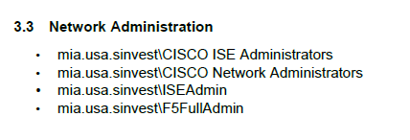
Source: 01 Policies and Procedures / BSI.IT.27.C7.03 PAM Definition of Privilege.pdf (page 7); NETWORK ADMINS tab of BSI.IT.27.C7.02 Q1 2026 Cert.xlsx

Appendix B - Certification Review Evidence
Exhibit B1: 2026 Q1 PAM BSI SOX Manager Certification - privileged network group memberships
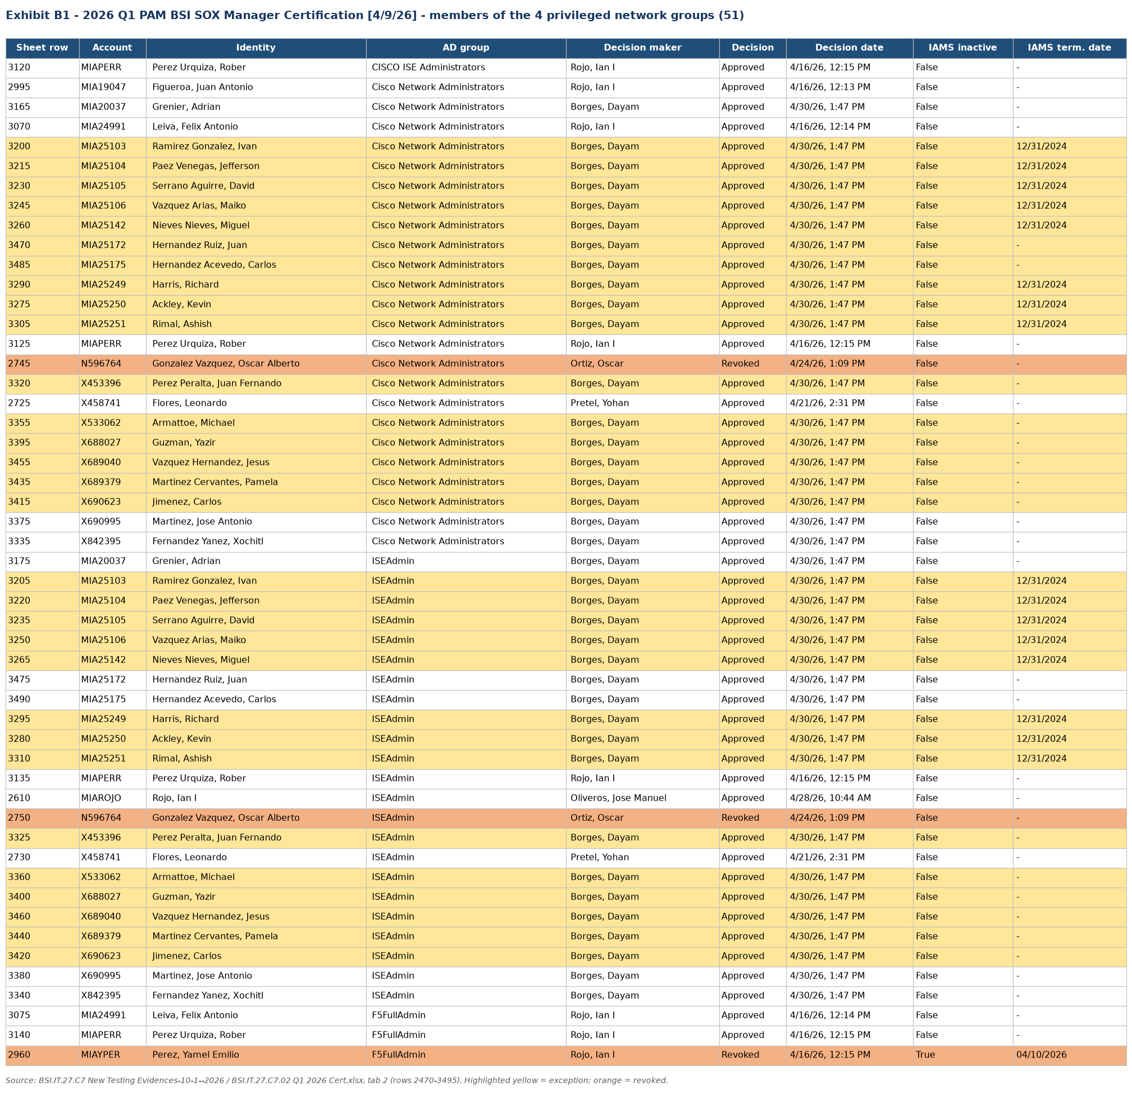
Source: BSI.IT.27.C7 Final 07.2025-06.2026 (extract rendered from the source workbook)

Appendix B - Certification Review Evidence
Exhibit B2: 2026 Q1 PAM BSI SOX Entitlement Owner Certification - service accounts
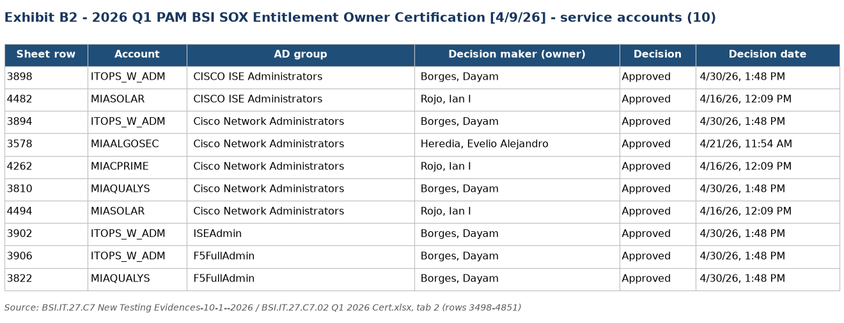
Source: BSI.IT.27.C7 Final 07.2025-06.2026 (extract rendered from the source workbook)

Appendix B - Certification Review Evidence
Exhibit B3: IAMS and Active Directory status of the approved accounts in exception (E1 / E2)
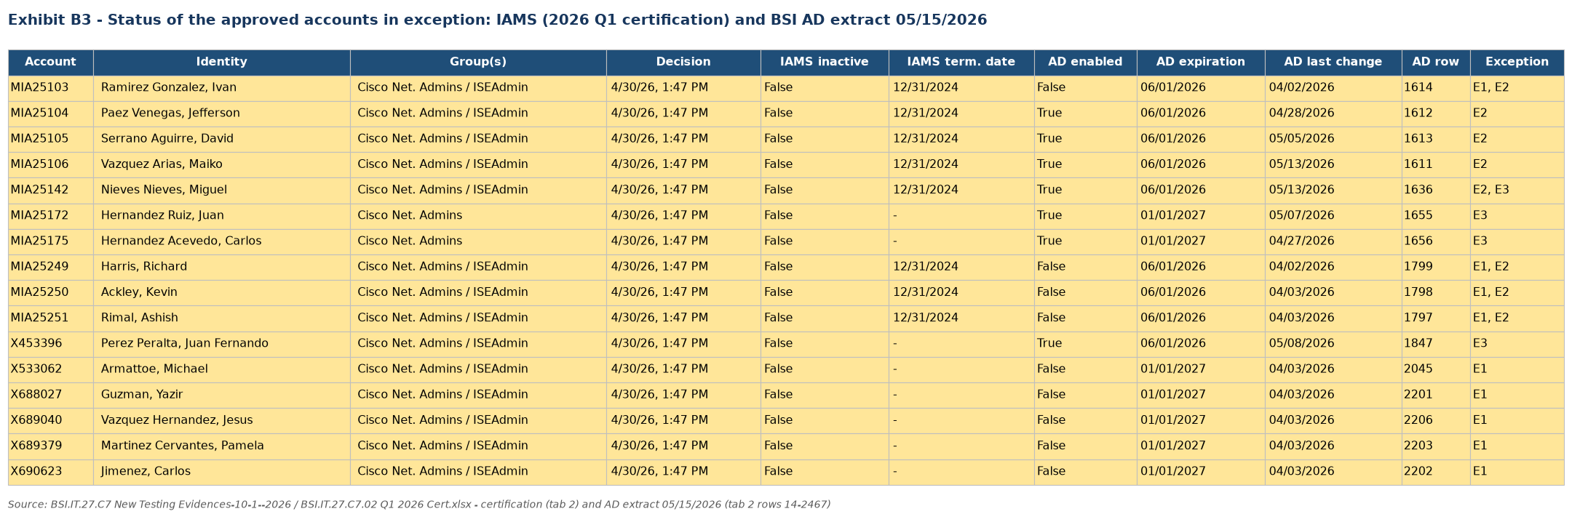
Source: BSI.IT.27.C7 Final 07.2025-06.2026 (extract rendered from the source workbook)

Appendix B - Certification Review Evidence
Exhibit B4: Memberships revoked in 2025 Q3 and approved again in 2026 Q1 (E3)
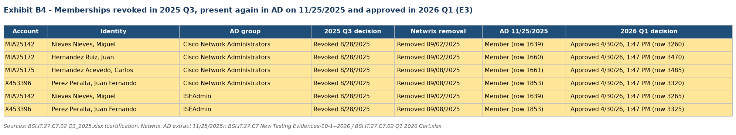
Source: BSI.IT.27.C7 Final 07.2025-06.2026 (extract rendered from the source workbook)

Appendix B - Certification Review Evidence
Exhibit B5: 2026 Q1 revocations removed within SLA (A6)
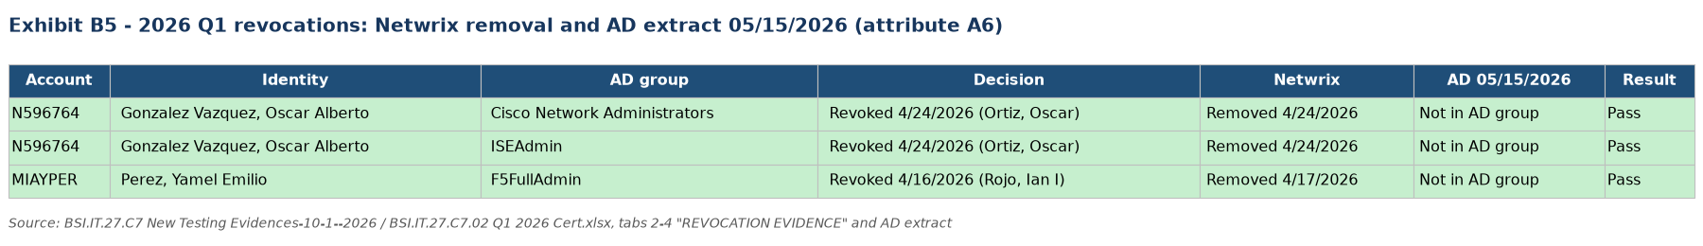
Source: BSI.IT.27.C7 Final 07.2025-06.2026 (extract rendered from the source workbook)

Appendix C - Population and Frequency Evidence
Exhibit C1: Population completeness and certification frequency
The population and frequency were validated as follows:
- BSI AD extract May 15, 2026: all 58 members of the four groups were certified in 2026 Q1; the 3 additional certified memberships (N596764 x2, MIAYPER) were revoked and are no longer in AD
- Certifications launched in the period: 2025 Q3 (August 1, 2025) and 2026 Q1 (April 9, 2026); 2025 Q4 not provided
- 2026 Q2 certification launched July 22, 2026 - after the period, used only as corroborative evidence
Result: Pass (population); Pass with observation (frequency)
Conclusion: The population is complete; one review was performed in each half of the period; the missing 2025 Q4 quarterly review is reported as an observation pending evidence.
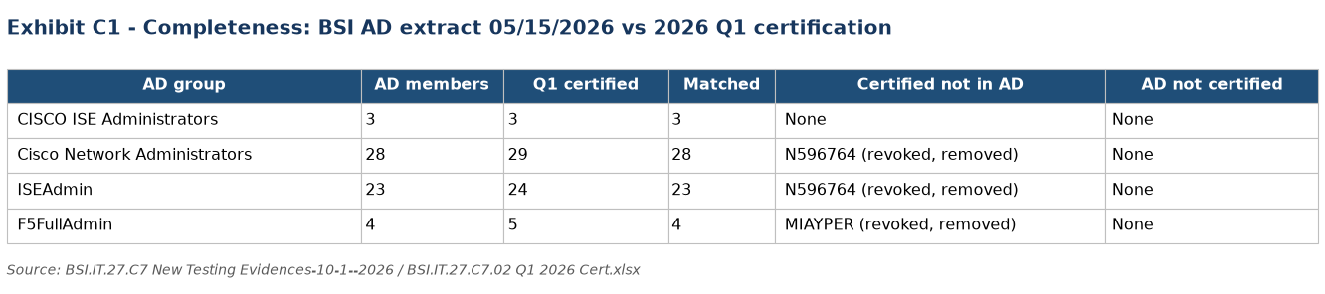
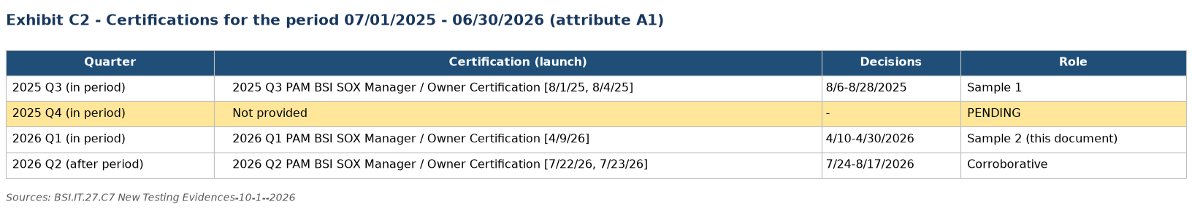
Source: BSI.IT.27.C7 Final 07.2025-06.2026 - BSI.IT.27.C7.02 Q1 2026 Cert.xlsx and Q3_2025.xlsx; 2026 Q2 certification exports.

Appendix D - Auditor Testing Narrative and Referenced Workbook
IT RCSA validated the Network Device Admin Account Review control for July 1, 2025 - June 30, 2026 by confirming the privileged network AD groups against the PAM Definition of Privilege, reconciling the 2026 Q1 certification to the BSI Active Directory extract of May 15, 2026, verifying reviewer assignment and decisions, assessing approved access against IAMS identity status, AD account status and prior revocations (including the AD extract of November 25, 2025 that showed revoked memberships present again), and confirming that the 2026 Q1 revocations were removed within SLA. Exceptions E1-E3 were identified in CISCO Network Administrators and ISEAdmin.
Referenced Excel Workbook: BSI.IT.27.C7.02 Q1 2026 Cert.xlsx; BSI.IT.27.C7.05 Testing Walkthrough - Step by Step.xlsx. See Section 4 for the tab-by-tab explanation and reviewer traceability.

